# CSS Grid

Problems for exercises and homework for the ["CSS Advanced" course @ SoftUni](https://softuni.bg/trainings/3042/css-advanced-july-2020).

## Simple Grid

Create a web page like the following:

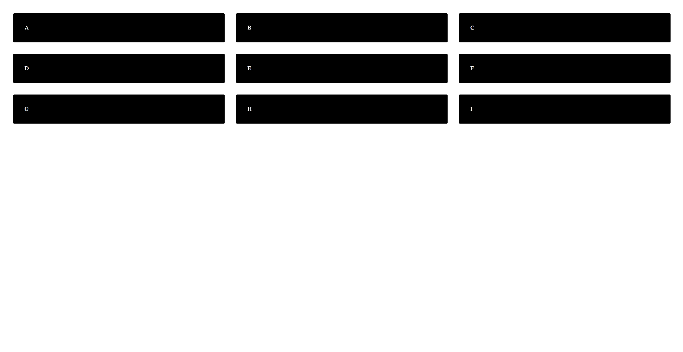

* Use article tags to create the containers with **letters** inside
* Set to the body display property grid

## Basic Blog Layout

Create a web page like the following:

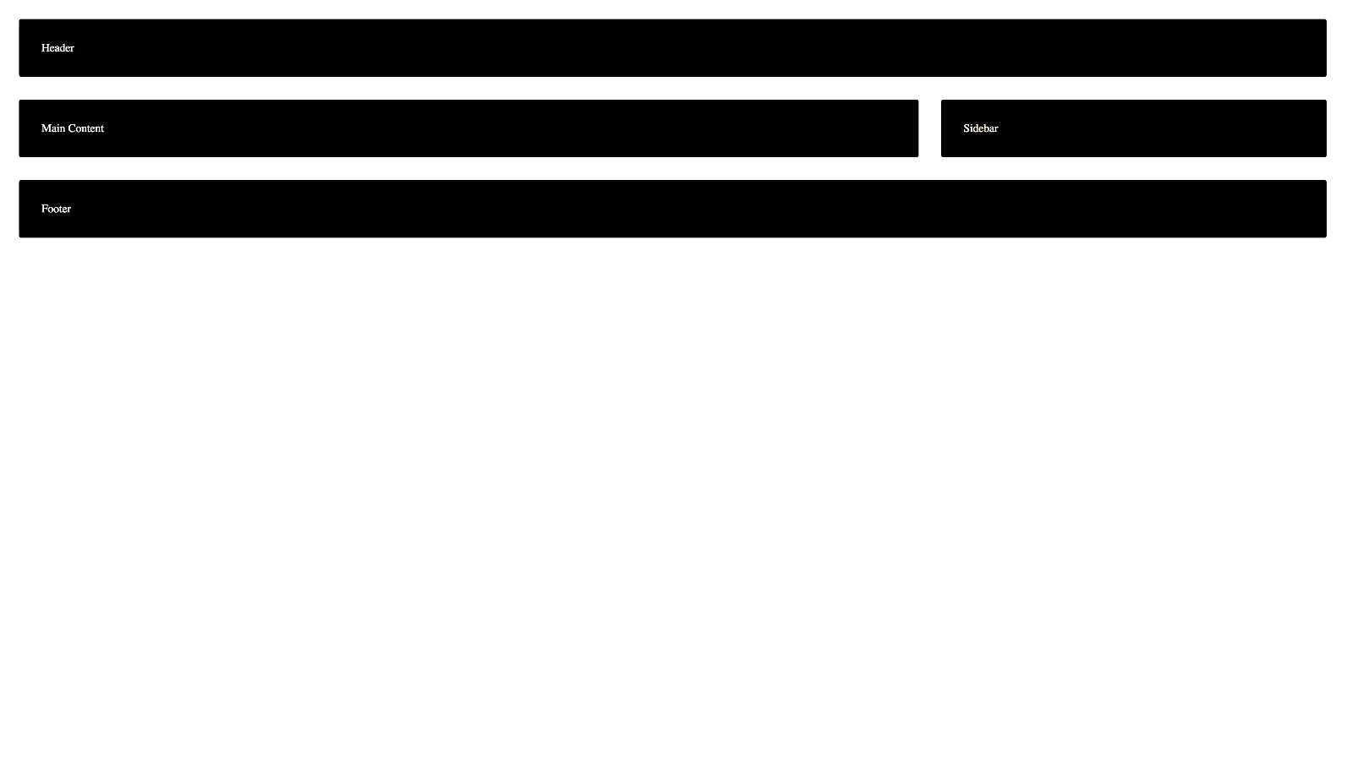

### Constraints

* Create the following elements using semantic tags:header,  main, sidebar and footer
* Arrange them in the basic blog layout by using display property grid

## Grid Named Areas

Create a web page like the following:

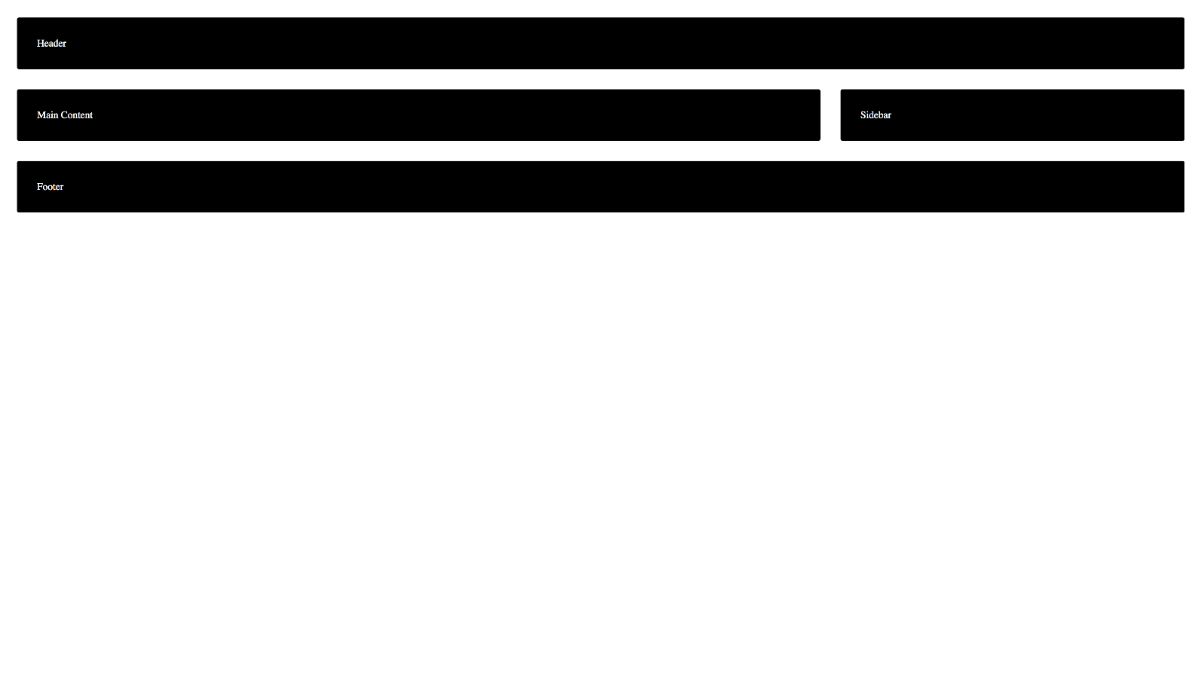

### Hints

* Copy the code from the previous exercise (**Basic Blog Layout**)
* Update the grid definition to use **named areas**
* Update the element placing to use the **named areas**

## Grid Areas Media Queries

Create a web page like the following for **desktop** and **mobile**:



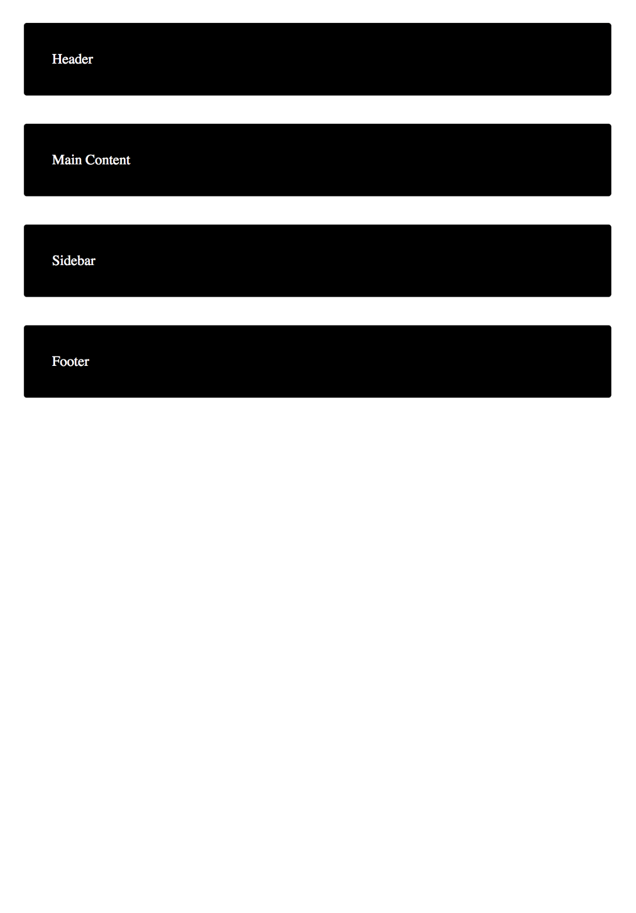

### Hints

* Copy the code from the previous exercise (**Grid Named Areas**)
* Redefine the grid using **Media** **Queries** for the screen **under** **1024px** **width**

## Colorful Statistic Diagram

Create a web page like the following:

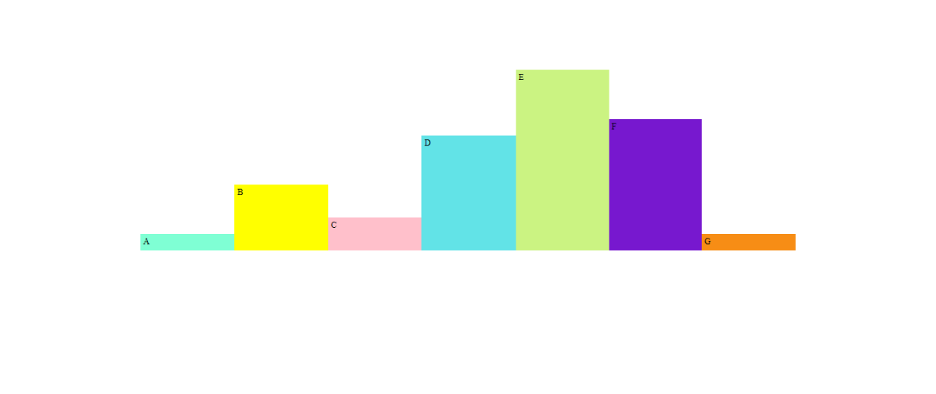

* Use article tags to create the containers with **letters** inside

## Grid Chess Board

Create a web page like the following:

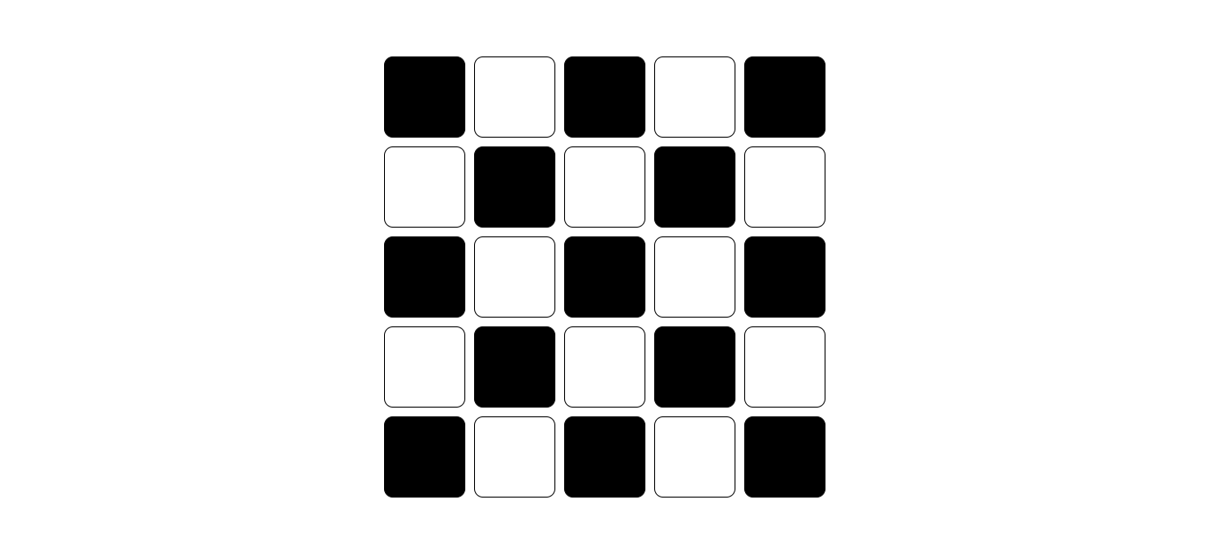

* Use div tags to create **25 empty boxes**

## Grid Gallery

Create a web page like the following for **desktop** and **mobile**:





* Use img tags to display the pictures
* Set to the body display property grid
* Redefine the grid using **Media** **Queries** when the screen has **800px** width